Egypt Inspiration (Decorative Art)

What it is? Egyptian Ceramic Faience Vase (pottery, or, “Egyptian paste”)
Where it is located in the world? Ancient Egypt
What time period is it from? 4000 BC
Which culture or person created it? Egyptians
Materials used? A low-fire mixture of ceramic materials containing sand, colorants, frits, and soluble salts.

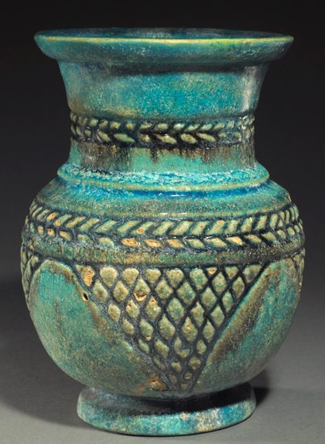

The word “faience” was originally named after a French term for Italian maiolica (Italian tin-glazed pottery), which came from Faenza in Northern Italy. The term is now used for a wide variety of pottery from several parts of the world, including many types of European painted wares. Faience can best be described as encompassing finely glazed ceramic beads, figures and other small objects found in Egypt. Egyptian faience is a self-glazing ceramic in that the salts in the wet paste come to the surface as it dries and develop a glaze when it is fired in the kiln. Because Egyptian faience is very different from other earthenware (pottery made from clay), some people prefer to call it “Egyptian paste.”

Egyptians used faience to create everything from small figurines, tiles and jewelry to intricate work that was of religious significance. The faience artwork was bright, and used bold colors. Turquoise and Lapis Lazuli were considered important because their color was associated with the rejuvenating Nile River and through this the Gods (re-birth). The Goddess Hathor, also known as the Lady of Turquoise or the Lady of Faience was the Goddess of love, music, dance and drink.

I personally love the attention to detail on many of these faience designs. I appreciate the bold color and sense of significance these pieces of work brought to the Egyptian culture.

http://www.royalathena.com/PAGES/EgyptianCatalog/Faience/BLS02JE.html

